(Approx. 433 words)

Help is Only a Few Clicks Away in Word
By Nancy DeMarte, 1st Vice President, Sarasota Technology User Group, FL
December 2018 issue, STUG Monitor
www.thestug.org / ndemarte (at) verizon.net

Microsoft Word has hundreds of tools to help us create professional-looking documents, with new tools being added all the time. Learning how to use these tools can be frustrating. Fortunately, Word has added ways to find help without leaving the application.

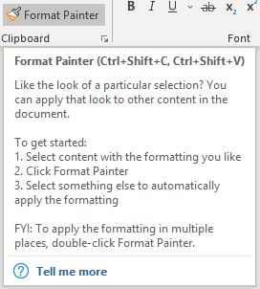
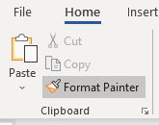
An example would be Format Painter, located on the Home tab on the left end of the Word ribbon. To learn the function of Format Painter, move your mouse pointer over its name on the ribbon, but don’t click. You will see the keyboard commands, definition, and steps in using this tool, as shown here.

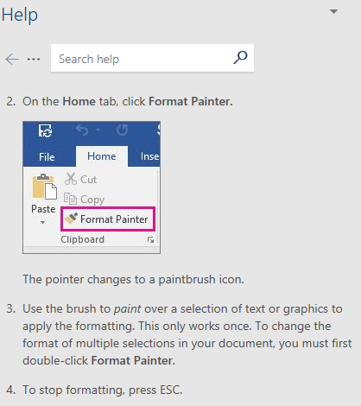
The “Tell me more” message below the definition offers more information. Click it to open a Help panel on the right side of the screen with more help on Format Painter. Here is a portion of the Help panel. Notice that the instructions have been expanded to offer even more help.

Sometimes we need help with performing a task in Word, like how to add section breaks to a page. On the right end of the ribbon’s Tab row is a small magnifying glass followed by “Tell me what you want to do.” Click this sentence and type a short phrase, like “Add section breaks.” Press Enter to open the box below.
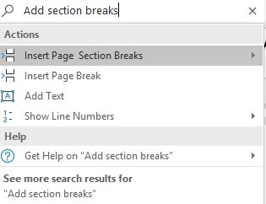
Clicking the highlighted line will take you to a gallery of page and section breaks with information about when to use each one. If that doesn’t answer your question, try clicking Help or See more search results for at the bottom of this box.

Word and some other Office applications also provide help with content. If you are unsure about the spelling of a word, for instance, right click the word and click Smart Lookup which appears in the dropdown menu. The results include correct spelling, definition, synonyms, and other information about the word from Wikipedia.
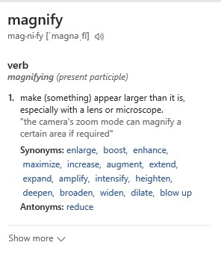
A new addition which provides more extensive help is the Help tab on the ribbon, which may only be available in the subscription version of Office, Office 365. Here is what the Help tab offers:
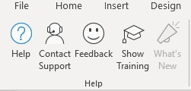

These are only some of Office Help tools located within the related application. Some older versions of Word may not contain all of these, which may be one reason to update to a newer version. Office 2019 is already released for the business version and will soon be available for home users. It will contain more recent tools than Office 2016 or prior versions.

